Computer programming

Final Project

Report

I.E.S. San Vicente
San Vicente del Raspeig (Alicante)
2015/2016

Teacher:
José Ignacio Cabanes

Student:
Jose Muñoz Lozano

1. Introduction
Project name
Representation of function

Made by
Jose Muñoz Lozano

Short description of the project
This is a “Representation of function” program. That will be analyzed the input by the user and will be represented in the axes. It is a graphical application that uses Windows Forms.

2. Functionality of the project
After entering the program, a welcome screen will we displayed, where the user can choose between:

• Play the application.
• Quit the application.

The application starts with an empty graph and a field where you enter the function to represent. There will also be some fields where you enter the X minimum and maximum X function to represent.

Also find some buttons to control the zoom and move around the graph. Together with a checkbox to decide whether to view the table of values or not.

The user can also choose to load functions of a file or save a file.

3. Screen prototype
The game screen will look like this:

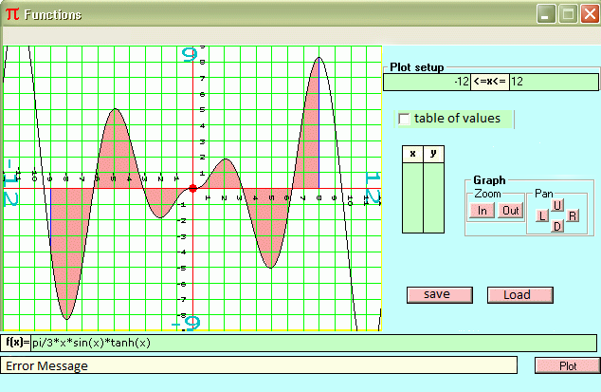

4.Analysis

4a. Requisites
Requisite | Date achieved
The program will allow a user to enter a function with a range of values and this will analyze it to represent
The program will allow a user to load a file functions
The program will allow a user to save functions in a file
The program will allow a user to view the table of values used to represent the function
The program will start showing an intro screen
The intro screen will allow user to enter the program or exit
The credits screen will display data about the programmer
The program will fail to enter an incorrect function
The program will use Windows Forms
The program will take the default values if no values are entered
Logarithmic function
Trigonometric function
Function between absolute value
Asymptotes

4b. Basic pseudocode

4c. Classes diagram
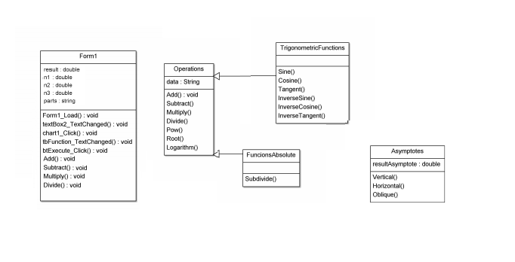

5. Initial planning and expected deliveries

5a. Expected deliveries
- Creation of the text box to enter the function, the field to notify you if there have been any errors, window graphics, the button will launch the analysis of the function, and implement the analysis of the introduced auxiliary functions to add, subtract, multiply and dividing two values ​​and the function.

- Implementation of the analysis when more than two values numeric ​​and the two operations are the same, two sums two subtractions or two multiplications.

- Implementation when more than two values numeric one x and the two operations only multiply with sum and the priority order to perform, multiplication and division they have done before addition and subtraction.

- Fix memory and attempt to implement when two numerical values, X and operations are add, subtract, multiply and divide.

- Implement when the user enters two numerical values, one X and operations are add and multiply (i.e. X*5+1).

- Screen credits, and check box to display the table of values ​​of X and Y. Create help menu on nomenclature of roots, exponentials, and logarithms (log) (the roots are made as the exponentials, i.e. square roots: (function)^(1/2), generic roots: (function)^(1/index)).

- Implement when the user enters two numerical values, one X and operations are divide and multiply, and subtract and multiply

- Implement buttons saved in a file function, and file upload function. Implement when the user enters two numerical values, one X and operations are add and divide (i.e. 1+x/5).

- Implement trigonometric functions, sine, cosine, and tangent

- Implement when the user enters two numerical values, one X and operations are subtract and divide, and multiply and divide (i.e. 1-x/5, 6*x/5).

- Establish the order of priority when the function has parentheses, inside the parentheses is done first and then the rest of the operations (e.g. 5+(8*x)).

- Create splash screen with two buttons, one to start the program and another to exit. Make them work both buttons. Create text box to enter range values ​​of X, and to implement the code.

- Interpret what the user entered, simple powers as a high value to a high number or a number and square roots parentheses.

- Interpreting what the user entered the potencies as high value to one or more digits or a high one or more digits parentheses, and perform roots index n.

- Create buttons for zoom and pan around the graph. Along the implementation of scroll on the graph to move horizontally and vertically.

- Implement analysis function to find where they begin logarithms and performing said logarithm with one or more digits.

- Implement trigonometric functions, sine, cosine, and tangent with the previous analysis of where they are in the function and it encompasses elements.

- Second implementation of trigonometric functions, now the inverse sine, cosine and tangent will. And implementation of logic to solve the parentheses containing another operation such as logarithms, trigonometric function; as they resolved from the inside outward.

- First version to analyze a function between absolute value of you must take the entire function and create two functions starting it where zero is made the function, changing the operations of addition by subtraction, and another leaving the additions and subtractions as they are.

- Second version of between absolute value function when the function is zero at more than one point, you have to create more than two functions from the original study in which the signs are changed and which not.

- Implement representing vertical and horizontal or oblique asymptotes when x or y have infinite.

5b. Real deliveries
- Version 1 (May 13): Creation of the text box to enter the function, the field to notify you if there have been any errors, window graphics, the button will launch the analysis of the function, and implement the analysis of the introduced auxiliary functions to add, subtract, multiply and dividing two values ​​and the function.
- Version 2 (May 23): Implementation of the analysis when more than two values numeric ​​and the two operations are the same, two sums two subtractions or two multiplications
- Version 3 (May 27): The program make multiplies with add
- Version 4 (May 30): Delivery made by Monica
- Version 5 (May 31): The program make multiplies with divide and multiplies with subtract
- Version 6 (June 1): Load and save in file, and first version to make divisions with sums (i.e. 1+x/5)
- Version 7 (June 2): Second version to make divisions with sums (i.e. 1+5/x). And the read file functions are stored in a queue and will dequeue, when there are no more functions to represent the user is notified.
- Version 8 (June 6): First version of establish the order of priority when the function has parentheses, inside the parentheses is done first and then the rest of the operations (i.e. 1+(8*x+1) DONE)
- Version 9 (June 7): Third version to make divisions with sums (1+x/5, x/5+1).
- Version 10 (June 8): Implement trigonometric functions, sine, cosine and tangent
- Version 11 (June 9): Fix Trigonometric functions sine, cosine, tangent, and implement box of values X

6. File formats

6a. Plain files format
funtion.rof
The range of values ​​of X is optional, and in this version is discarded if read this.

X*5+1
###
5/x+9
-5<x<20
###
X*6
###

6b. Entity-Relationship Diagram (If needed)

7. Problems found and solutions

8. Improvements or restrictions to the starting design

9. Screenshots of the final project

10. Source code of the final project

